Angel Velazquez

CST-307

Dr. Citro

**Program 2**

Github repository link - <https://github.com/angel-vlzqz/Computer-Architecture>

The code for program 2 of this CLC was straightforward and included debugging. I started experimenting with branch statements to get them to work. I ran into a bug where I had two conditional branch statements that would execute due to poor logic. I managed to get away with using a single-branch statement. I included a terminate program block in the branch statement and the bottom of the primary function. I am still determining if this is a good assembler practice and will have to place my mercy among the programming gods, but the code runs and looks clean.

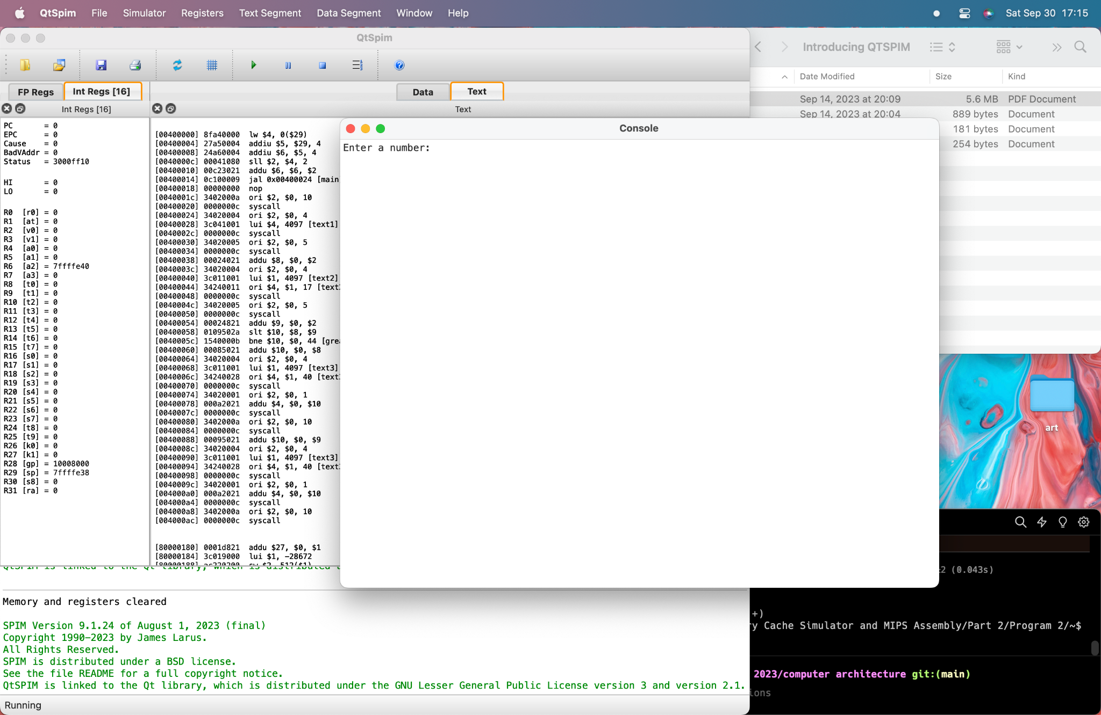

The program asks the user to enter a number.

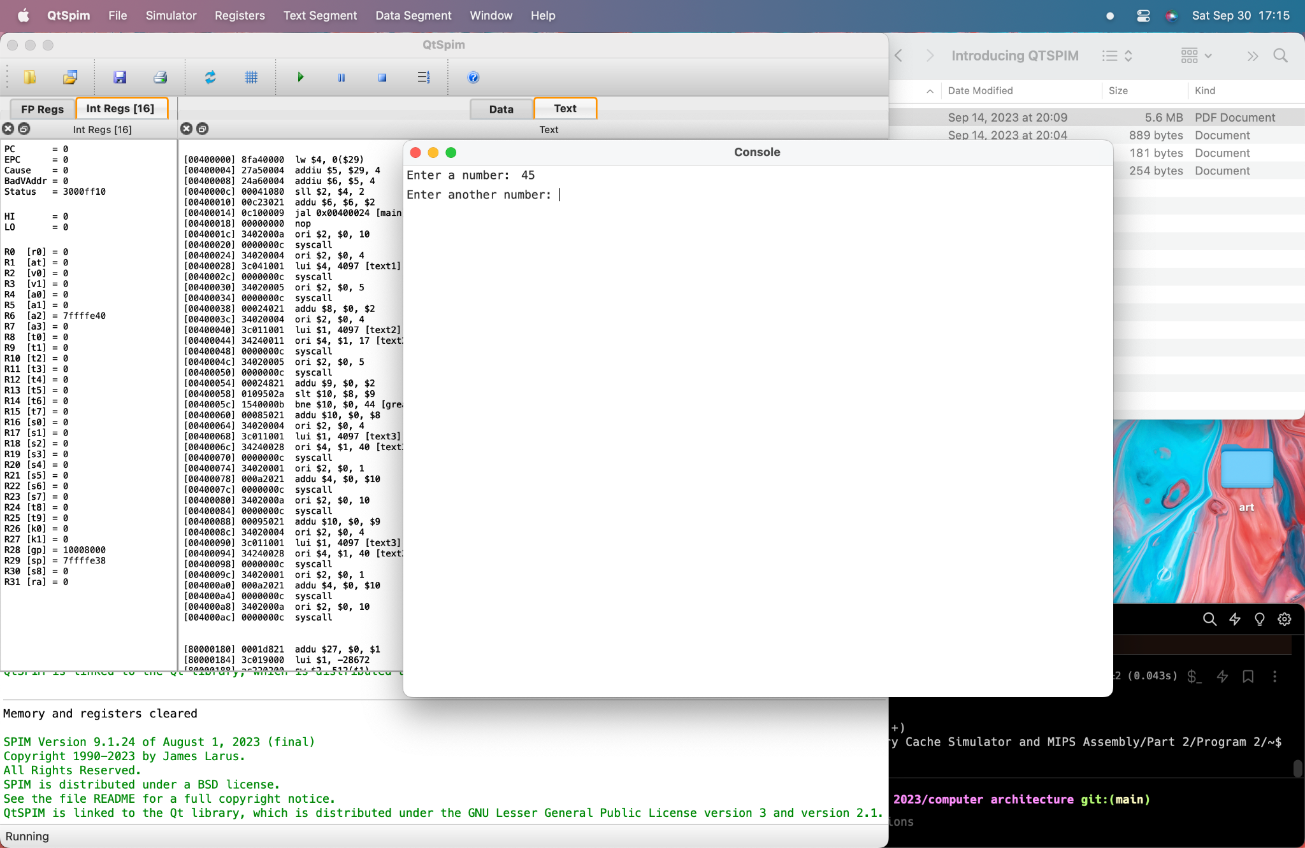

The program asks the user to enter another number.

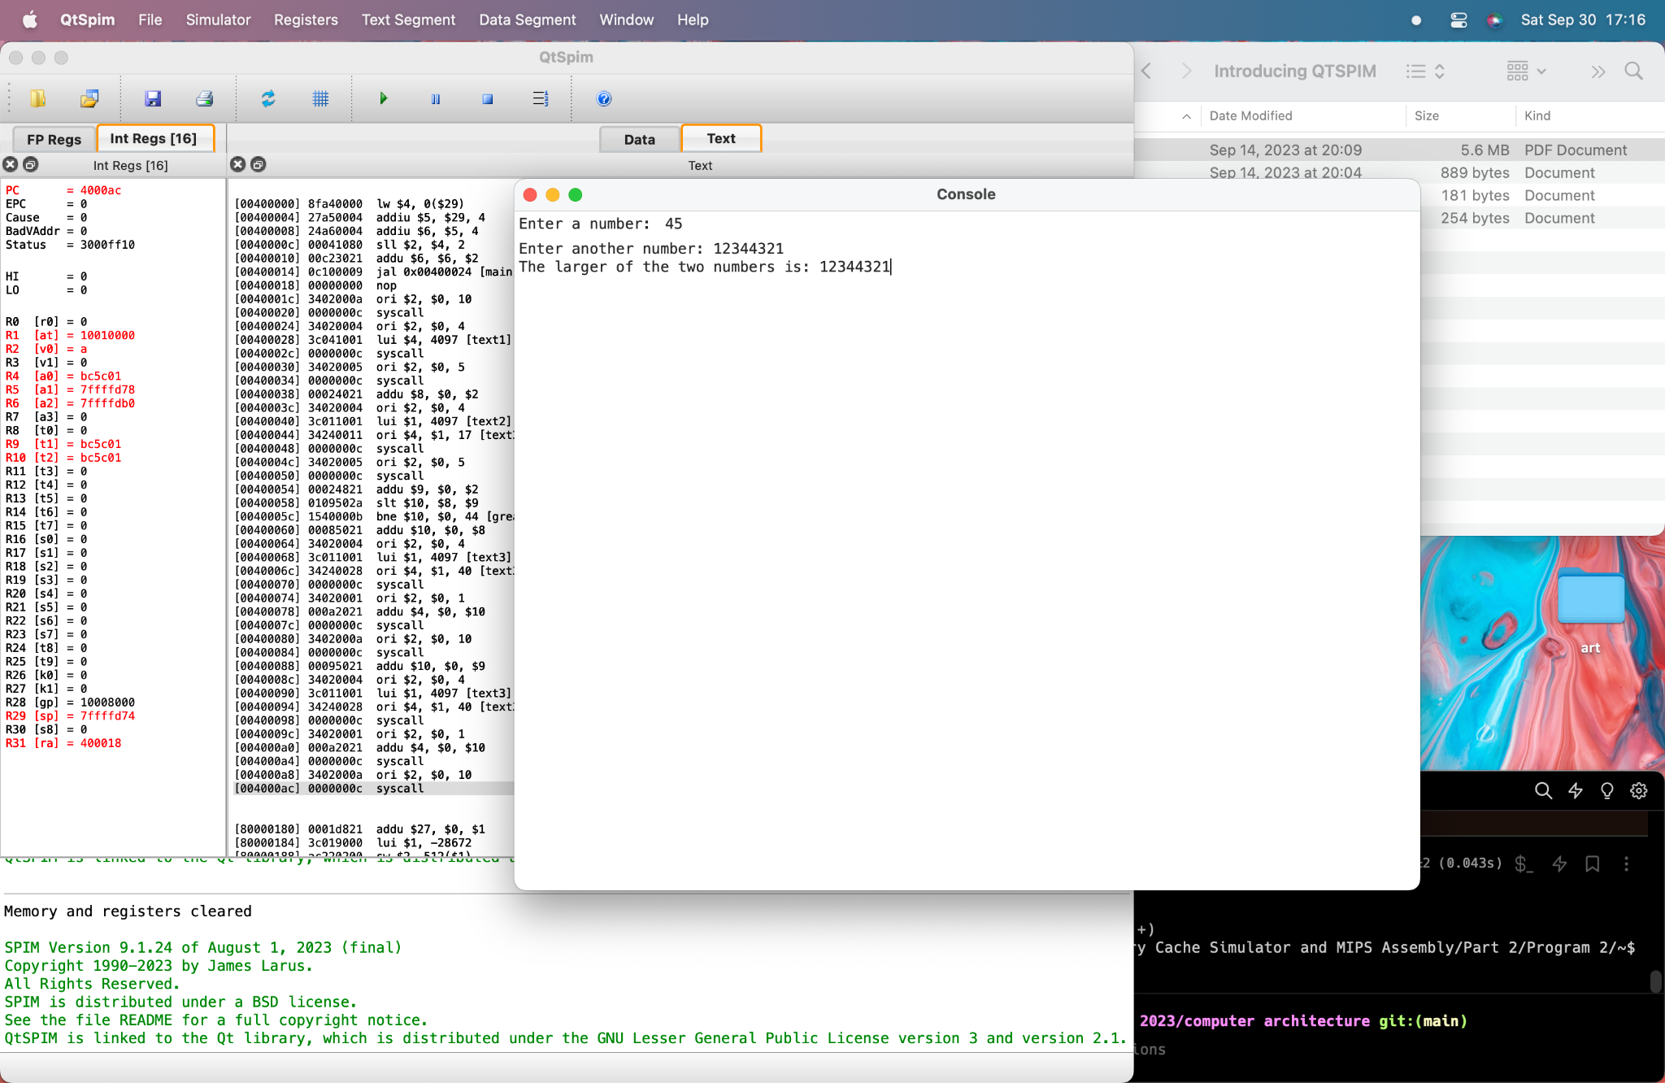

The program prints out the larger of the two numbers input by the user in realtime